**Role-Based Access Control (RBAC)**

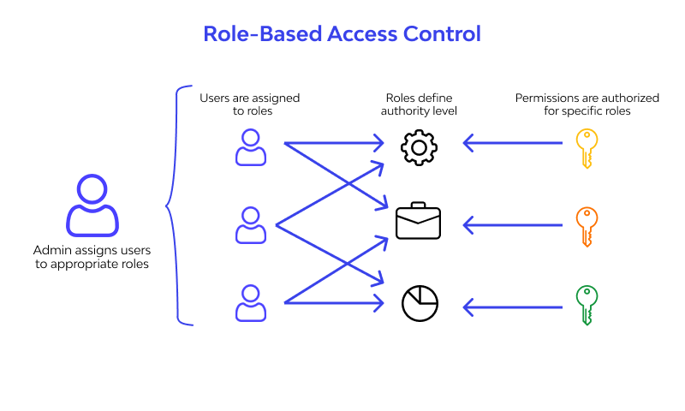

**Role-Based Access Control (RBAC)** is a security mechanism that restricts system access based on a user's assigned role. In Azure, RBAC lets you manage who can **view, edit, or manage resources** by assigning predefined roles.

|  |  |  |
| --- | --- | --- |
| **Feature** | **Azure Active Directory (Azure AD)** | **Role-Based Access Control (RBAC)** |
| **Purpose** | Identity and access management service | Authorization model for managing access to Azure resources |
| **Function** | Authenticates users and devices | Grants permissions based on roles (e.g., Reader, Contributor) |
| **Scope** | Manages user login, SSO, MFA, groups | Controls what authenticated users can do in Azure |

**Azure AD = Who you are (****identity****) RBAC = What you can do (permissions)**